**LAPORAN AKHIR**

**SISTEM CERDAS DAN PENDUKUNG KEPUTUSAN**



**DISUSUN OLEH:**

|  |  |  |
| --- | --- | --- |
| **NIM** | **:** | **123220010**  **123220021** |
| **NAMA** | **:** | **Wijdan Akhmad Subarkat**  **Mohamad Risqi Aditiya** |
| **KELAS** | **:** | **IF - E** |
| **DOSEN** | **:** | **Dr. Herlina Jayadianti, S.T, M.T** |

**PROGRAM STUDI INFORMATIKA**

**JURUSAN TEKNIK INFORMATIKA**

**FAKULTAS TEKNIK INDUSTRI**

**UNIVERSITAS PEMBANGUNAN NASIONAL “VETERAN”**

**YOGYAKARTA**

**2024**

# **KATA PENGANTAR**

Puji syukur kami panjatkan kepada Tuhan Yang Maha Esa yang senantiasa mencurahkan rahmat dan hidayah-Nya sehingga kami dapat menyelesaikan Mata Kuliah Sistem Cerdas dan Pendukung Keputusan serta laporan akhir Sistem Cerdas dan Pendukung Keputusan. Adapun laporan ini berisi tentang tugas dan evaluasi dari hasil pembelajaran materi Fuzzy.

Tidak lupa ucapan terima kasih kepada Ibu Dr. Herlina Jayadianti, S.T, M.Tselaku dosen pengampu mata kuliah iniyang selalu membimbing dan mengajari kami dalam melaksanakan pembelajaran mata kuliah Sistem Cerdas dan Pendukung Keputusan dan dalam menyusun laporan ini. Laporan ini masih sangat jauh dari kesempurnaan, oleh karena itu kritik serta saran yang membangun kami harapkan untuk menyempurnakan laporan akhir ini.

Atas perhatian dari semua pihak yang membantu penulisan ini, kami ucapkan terima kasih. Semoga laporan ini dapat dipergunakan seperlunya.

Yogyakarta, 06 Juli 2024

Penyusun Penyusun

Wijdan Akhmad Subarkat Mohamad Risqi Aditiya

# **DAFTAR ISI**

KATA PENGANTAR ii

DAFTAR ISI iii

BAB 1. STUDI KASUS 1

1.1 Permasalahan : 1

1.2 Ditanyakan : 1

BAB 2. PERHITUNGAN 2

2.1 Definisi Awal 2

2.2 Aturan Fuzzy 2

2.3 Rumus Fuzzy 2

2.4 Penerapan Aturan Fuzzy 3

2.5 Menentukan Output CRISP 4

BAB 3. SOURCE CODE 5

3.1 Source Code Program Matlab 5

3.2 Screenshot Program 11

# **BAB 1**

# **STUDI KASUS**

## **1.1 Permasalahan :**

Suatu perusahaan jasa ekspedisi melayani pengiriman paket dengan karakteristik permintaan yang berfluktuasi setiap hari. Dari data satu bulan terakhir, permintaan tertinggi mencapai 6000 paket/hari, dan permintaan terendah sampai 1500 paket/hari.

Persediaan kendaraan dan kapasitas di gudang juga bervariasi, dengan jumlah maksimal 80 kendaraan dan minimal 10 kendaraan tersedia setiap hari.

Dengan segala keterbatasannya, perusahaan baru mampu menangani maksimum 7000 paket/hari dan demi efisiensi, perusahaan paling tidak harus menangani 2500 paket/hari.

Perusahaan ingin menggunakan logika fuzzy untuk menentukan jumlah paket yang harus ditangani setiap hari berdasarkan data permintaan dan persediaan kendaraan.

## **1.2 Ditanyakan :**

Berapa jumlah paket yang harus ditangani oleh perusahaan jasa ekspedisi, jika permintaan sebanyak 4500 paket dan persediaan kendaraan di gudang adalah 50 kendaraan?

# **BAB 2**

# **PERHITUNGAN**

## **2.1 Definisi Awal**

Terdapat 3 Variabel Himpunan :

1. Permintaan

permintaan tinggi mencapai 6000 paket/hari (Naik = 6000 paket/hari).

permintaan terendah sampai 1500 paket/hari (Turun = 1500 paket/hari).

1. Persedian

jumlah maksimal 80 kendaraan (Banyak = 80 kendaraan).

jumlah minimal 10 kendaraan tersedia setiap hari (Sedikit = 10 kendaraan).

1. Jumlah Paket

menangani maksimum 7000 paket/hari (Bertambah = 7000 paket/hari).

paling tidak harus menangani 2500 paket/hari (Berkurang = 2500 paket/hari).

Jika Permintaan sebanyak 4500 paket dan persedian kendaraan di gudang adalah 50 kendaraan.

Maka

Permintaan = 4500 paket/hari.

Persedian = 50 kendaraan.

## **2.2 Aturan Fuzzy**

Aturan Fuzzy yang digunakan :

R1 : IF permintaan turun AND persediaan banyak THEN jumlah paket berkurang.

R2 : IF permintaan turun AND persediaan sedikit THEN jumlah paket berkurang.

R3 : IF permintaan naik AND persediaan banyak THEN jumlah paket bertambah.

R4 : IF permintaan naik AND persediaan sedikit THEN jumlah paket bertambah.

## **2.3 Rumus Fuzzy**

Menerapkan fuzzy untuk setiap variabelnya :

1. Variabel Permintaan

|  |  |
| --- | --- |
| μ Permintaan **TURUN[x]** | μ Permintaan **NAIK[x]** |
|  |  |

**Derajat/nilai Keanggotaan :**

|  |  |
| --- | --- |
| μ Permintaan **TURUN[4500]**  = (6000 - 4500) / 6000 - 1500  = 1500 / 4500  = **0,333** | μ Permintaan **NAIK[4500]**  = (4500 - 1500) / 6000 - 1500  = 3000 / 4500  = **0,667** |

1. Variabel Persedian

|  |  |
| --- | --- |
| μ Persedian **SEDIKIT[y]** | μ Persedian **BANYAK[y]** |
|  |  |

**Derajat/nilai Keanggotaan :**

|  |  |
| --- | --- |
| μ Persedian **SEDIKIT[50]**  = (80 - 50) / 80 - 10  = 30 / 70  = **0,429** | μ Persedian **BANYAK[50]**  = (50 - 10) / 80 - 10  = 40 / 70  = **0,572** |

1. Variabel Jumlah Paket

|  |  |
| --- | --- |
| μ Jumlah Paket **BERKURANG[z]** | μ Jumlah Paket **BERTAMBAH[z]** |
|  |  |

## **2.4 Penerapan Aturan Fuzzy**

Penerapan Aturan Fuzzy dengan rumus fuzzy yang sudah didapatkan :

1. Aturan 1

R1: IF permintaan **turun** AND persediaan **banyak** THEN jumlah paket **berkurang**

α predikat1 = μPermintaanTURUN റ μPersediaanBANYAK

= min(μPermintaanTURUN[4500] റ μPersediaanBANYAK[50])

= min(0,333 : 0,667) = **0,333**

Untuk α predikat1 = 0,33 pada himpunan jumlahPaketBERKURANG

= (7000 - z) / (7000-2500) = 0,333

⇒ **z1 = 5500,00**

1. Aturan 2

R2: IF permintaan **turun** AND persediaan **sedikit** THEN jumlah paket **berkurang**

α predikat2 = μPermintaanTURUN റ μPersediaanSEDIKIT

= min(μPermintaanTURUN[4500] റ μPersediaanSEDIKIT[50])

= min(0,333 : 0,429) = **0,333**

Untuk α predikat2 = 0,33 pada himpunan jumlahPaketBERKURANG

= (7000 - z) / (7000-2500) = 0,333

⇒ **z2 = 5500,00**

1. Aturan 3

R3: IF permintaan **naik** AND persediaan **banyak** THEN jumlah paket **bertambah**

α predikat3 = μPermintaanNAIK റ μPersediaanBANYAK

= min(μPermintaanNAIK[4500] റ μPersediaanBANYAK[50])

= min(0,667 : 0,571) = **0,571**

Untuk α predikat3 = 0,571 pada himpunan jumlahPaketBERTAMBAH

= (z - 2500) / (7000-2500) = 0,571

⇒ **z3 = 5071,43**

1. Aturan 4

R4: IF permintaan **naik** AND persediaan **sedikit** THEN jumlah paket **bertambah**

α predikat4 = μPermintaanNAIK റ μPersediaanSEDIKIT

= min(μPermintaanNAIK[4500] റ μPersediaanSEDIKIT[50])

= min(0,667: 0.429) = **0,429**

Untuk α predikat1 = 0,33 pada himpunan jumlahPaketBERTAMBAH

= (z - 2500) / (7000-2500) = 0,429

⇒ **z4 = 4428,57**

## **2.5 Menentukan Output CRISP**

Pada metode TSUKAMOTO untuk menentukan output crisp menggunakan rata-rata berbobot yaitu :





= 8462,69 / 1,667 = **5077,55**

Jadi jumlah paket yang harus ditangani **5077,55,** dibulatkan **5078**

# **BAB 3**

# **SOURCE CODE**

## **3.1 Source Code Program Matlab**

|  |
| --- |
| function varargout = fuzzy_gui(varargin)  % FUZZY_GUI MATLAB code for fuzzy_gui.fig  % FUZZY_GUI, by itself, creates a new FUZZY_GUI or raises the existing  % singleton*.  %  % H = FUZZY_GUI returns the handle to a new FUZZY_GUI or the handle to  % the existing singleton*.  %  % FUZZY_GUI('CALLBACK',hObject,eventData,handles,...) calls the local  % function named CALLBACK in FUZZY_GUI.M with the given input arguments.  %  % FUZZY_GUI('Property','Value',...) creates a new FUZZY_GUI or raises the  % existing singleton*. Starting from the left, property value pairs are  % applied to the GUI before fuzzy_gui_OpeningFcn gets called. An  % unrecognized property name or invalid value makes property application  % stop. All inputs are passed to fuzzy_gui_OpeningFcn via varargin.  %  % *See GUI Options on GUIDE's Tools menu. Choose "GUI allows only one  % instance to run (singleton)".  %  % See also: GUIDE, GUIDATA, GUIHANDLES  % Edit the above text to modify the response to help fuzzy_gui  % Last Modified by GUIDE v2.5 31-May-2024 09:40:24  % Begin initialization code - DO NOT EDIT  gui_Singleton = 1;  gui_State = struct('gui_Name', mfilename, ...  'gui_Singleton', gui_Singleton, ...  'gui_OpeningFcn', @fuzzy_gui_OpeningFcn, ...  'gui_OutputFcn', @fuzzy_gui_OutputFcn, ...  'gui_LayoutFcn', [] , ...  'gui_Callback', []);  if nargin && ischar(varargin{1})  gui_State.gui_Callback = str2func(varargin{1});  end  if nargout  [varargout{1:nargout}] = gui_mainfcn(gui_State, varargin{:});  else  gui_mainfcn(gui_State, varargin{:});  end  % End initialization code - DO NOT EDIT  % --- Executes just before fuzzy_gui is made visible.  function fuzzy_gui_OpeningFcn(hObject, eventdata, handles, varargin)  % This function has no output args, see OutputFcn.  % hObject handle to figure  % eventdata reserved - to be defined in a future version of MATLAB  % handles structure with handles and user data (see GUIDATA)  % varargin command line arguments to fuzzy_gui (see VARARGIN)  % Choose default command line output for fuzzy_gui  handles.output = hObject;  % Update handles structure  guidata(hObject, handles);  % UIWAIT makes fuzzy_gui wait for user response (see UIRESUME)  % uiwait(handles.figure1);  % --- Outputs from this function are returned to the command line.  function varargout = fuzzy_gui_OutputFcn(hObject, eventdata, handles)  % varargout cell array for returning output args (see VARARGOUT);  % hObject handle to figure  % eventdata reserved - to be defined in a future version of MATLAB  % handles structure with handles and user data (see GUIDATA)  % Get default command line output from handles structure  varargout{1} = handles.output;  function permintaan_Callback(hObject, eventdata, handles)  % hObject handle to permintaan (see GCBO)  % eventdata reserved - to be defined in a future version of MATLAB  % handles structure with handles and user data (see GUIDATA)  % Hints: get(hObject,'String') returns contents of permintaan as text  % str2double(get(hObject,'String')) returns contents of permintaan as a double  % --- Executes during object creation, after setting all properties.  function permintaan_CreateFcn(hObject, eventdata, handles)  % hObject handle to permintaan (see GCBO)  % eventdata reserved - to be defined in a future version of MATLAB  % handles empty - handles not created until after all CreateFcns called  % Hint: edit controls usually have a white background on Windows.  % See ISPC and COMPUTER.  if ispc && isequal(get(hObject,'BackgroundColor'), get(0,'defaultUicontrolBackgroundColor'))  set(hObject,'BackgroundColor','white');  end  function persedian_Callback(hObject, eventdata, handles)  % hObject handle to persedian (see GCBO)  % eventdata reserved - to be defined in a future version of MATLAB  % handles structure with handles and user data (see GUIDATA)  % Hints: get(hObject,'String') returns contents of persedian as text  % str2double(get(hObject,'String')) returns contents of persedian as a double  % --- Executes during object creation, after setting all properties.  function persedian_CreateFcn(hObject, eventdata, handles)  % hObject handle to persedian (see GCBO)  % eventdata reserved - to be defined in a future version of MATLAB  % handles empty - handles not created until after all CreateFcns called  % Hint: edit controls usually have a white background on Windows.  % See ISPC and COMPUTER.  if ispc && isequal(get(hObject,'BackgroundColor'), get(0,'defaultUicontrolBackgroundColor'))  set(hObject,'BackgroundColor','white');  end  function jmlPaket_Callback(hObject, eventdata, handles)  % hObject handle to jmlPaket (see GCBO)  % eventdata reserved - to be defined in a future version of MATLAB  % handles structure with handles and user data (see GUIDATA)  % Hints: get(hObject,'String') returns contents of jmlPaket as text  % str2double(get(hObject,'String')) returns contents of jmlPaket as a double  % --- Executes during object creation, after setting all properties.  function jmlPaket_CreateFcn(hObject, eventdata, handles)  % hObject handle to jmlPaket (see GCBO)  % eventdata reserved - to be defined in a future version of MATLAB  % handles empty - handles not created until after all CreateFcns called  % Hint: edit controls usually have a white background on Windows.  % See ISPC and COMPUTER.  if ispc && isequal(get(hObject,'BackgroundColor'), get(0,'defaultUicontrolBackgroundColor'))  set(hObject,'BackgroundColor','white');  end  % --- Executes on button press in pushbutton1.  function pushbutton1_Callback(hObject, eventdata, handles)  % hObject handle to pushbutton1 (see GCBO)  % eventdata reserved - to be defined in a future version of MATLAB  % handles structure with handles and user data (see GUIDATA)  permin1 = get(handles.permintaan, 'string');  persed1 = get(handles.persedian, 'string');  if isempty(permin1) && isempty(persed1)  errordlg('Masukan permintaan dan persedian terlebih dahulu', 'Error');  return;  end  permin = str2double(permin1);  persed = str2double(persed1);  fis = readfis('fuzzy.fis');  % Debug: cek FIS apakah benar  if isempty(fis)  errordlg('File FIS tidak ada, cari terlebih dahulu fis nya', 'Error');  return;  end  % Plot fungsi untuk Permintaan  axes(handles.axes1);  plotmf(fis, 'input', 1);  title('Permintaan');  xlabel('Permintaan');  ylabel('Membership Value');  hold on;  % Tambah vertikal untuk nilai  stem(permin, 1, 'r');  hold off;  % Plot fungsi untuk Persediaan  axes(handles.axes2);  plotmf(fis, 'input', 2);  title('Persedian');  xlabel('Persedian');  ylabel('Membership Value');  hold on;  % Tambah vertikal untuk nilai  stem(persed, 1, 'r');  hold off;  % Eval  result = evalfis([permin, persed], fis);  % Plot fungsi untuk Hasil  axes(handles.axes3);  plotmf(fis, 'output', 1);  title('Jumlah Paket');  xlabel('Jumlah Paket');  ylabel('Membership Value');  hold on;  % Tambah vertikal untuk nilai  stem(result, 1, 'r');  hold off;  % display  set(handles.jmlPaket, 'string', num2str(result));  % --- Executes during object creation, after setting all properties.  function axes1_CreateFcn(hObject, eventdata, handles)  % hObject handle to axes1 (see GCBO)  % eventdata reserved - to be defined in a future version of MATLAB  % handles empty - handles not created until after all CreateFcns called  % Hint: place code in OpeningFcn to populate axes1  % --- Executes during object creation, after setting all properties.  function axes2_CreateFcn(hObject, eventdata, handles)  % hObject handle to axes2 (see GCBO)  % eventdata reserved - to be defined in a future version of MATLAB  % handles empty - handles not created until after all CreateFcns called  % Hint: place code in OpeningFcn to populate axes2 |

**Tabel 3.1. Source Code Matlab ‘fuzzy_gui.m’**

|  |
| --- |
| **[**System]  Name='fuzzy'  Type='mamdani'  Version=2.0  NumInputs=2  NumOutputs=1  NumRules=4  AndMethod='min'  OrMethod='max'  ImpMethod='min'  AggMethod='max'  DefuzzMethod='centroid'  [Input1]  Name='Permintaan'  Range=[1500 6000]  NumMFs=2  MF1='TURUN':'trimf',[1500 1500 6000]  MF2='NAIK':'trimf',[1500 6000 6000]  [Input2]  Name='Persedian'  Range=[10 80]  NumMFs=2  MF1='SEDIKIT':'trimf',[10 10 80]  MF2='BANYAK':'trimf',[10 80 80]  [Output1]  Name='JmlPaket'  Range=[2500 7000]  NumMFs=2  MF1='BERKURANG':'trimf',[2500 2500 7000]  MF2='BERTAMBAH':'trimf',[2500 7000 7000]  [Rules]  1 2, 1 (1) : 1  1 1, 1 (1) : 1  2 2, 2 (1) : 1  2 1, 2 (1) : 1 |

**Tabel 3.2. Source Code Matlab ‘fuzzy.fis’**

## **3.2 Screenshot Program**

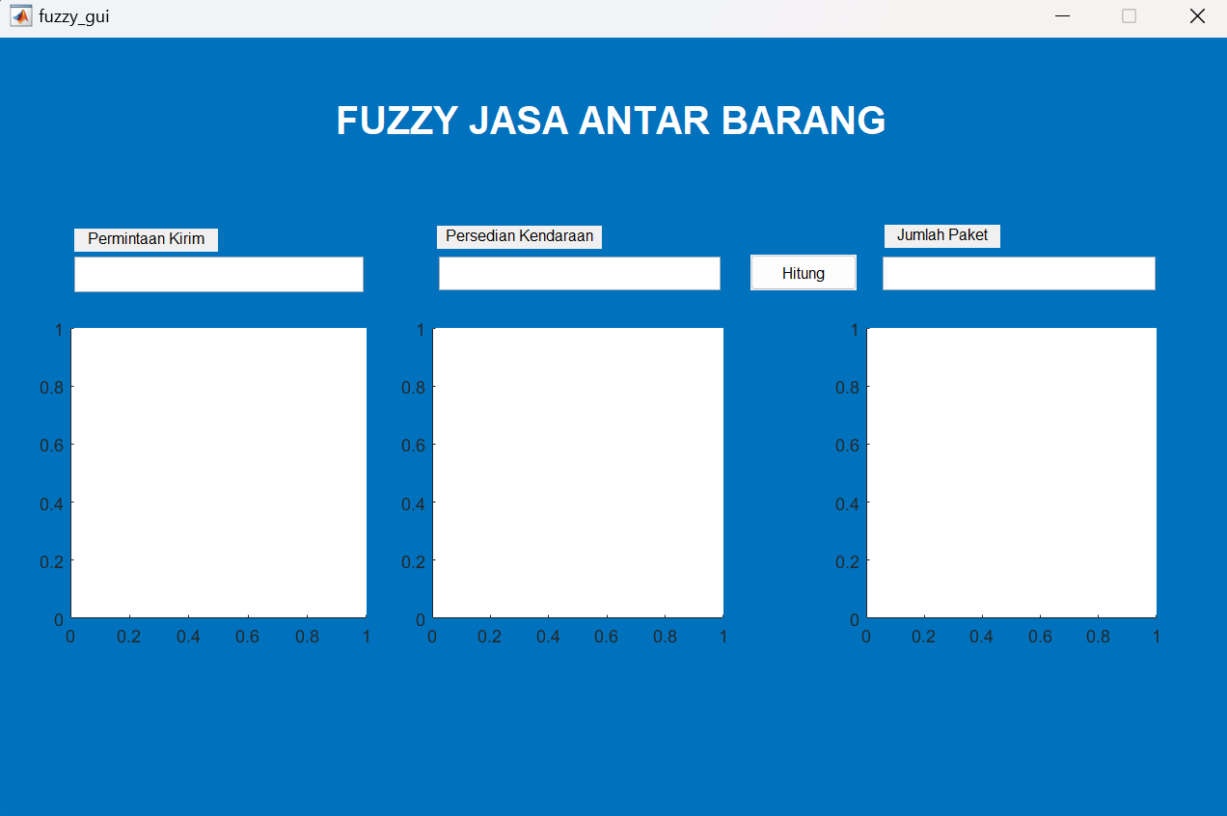

**Gambar 3.1. Tampilan Awal Program**

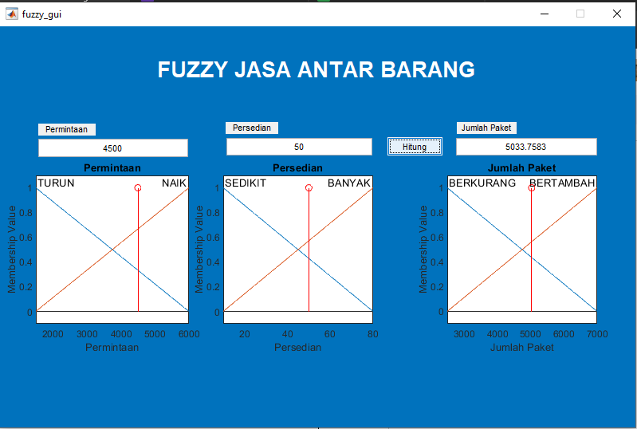

**Gambar 3.2. Setelah diinputkan data sesuai soal**